Run Anywhere Development

- User Stories:
- Authorize
- user login
- user logout
- user signup
- user change password
- activation link embed user email (email + activation code + 48 hour limit)(?)
adv: so we know if the user has activated or not.
if activate, instruct to login
if email not exist, means: not signup, or pass activate time window

Mock UI:
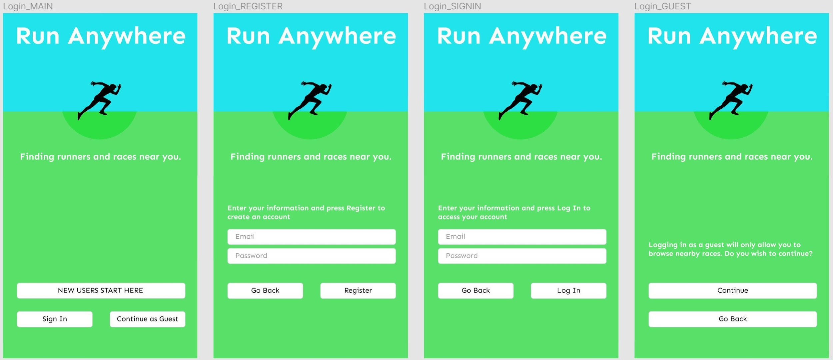

- GUEST
- as guest, can find races/events
- as guest, can search results
- as guest, check special race result and checkpoint timing
- as guest, live track runner at race time( tbd?)

Mock UI:
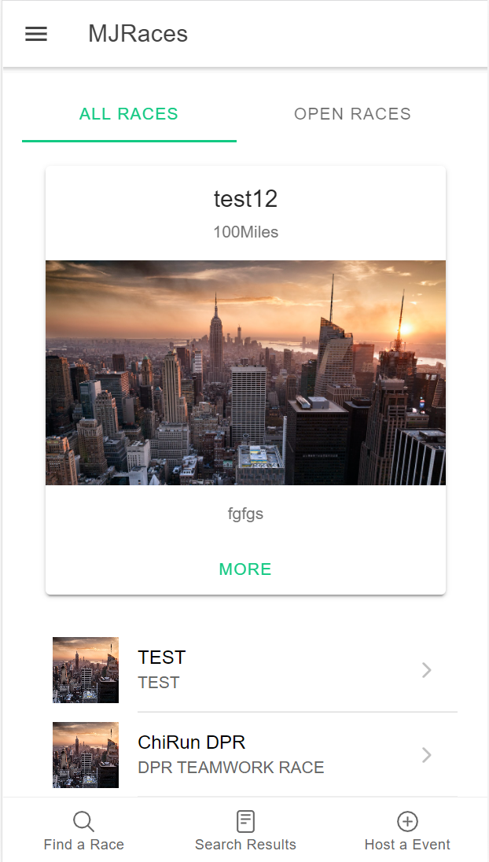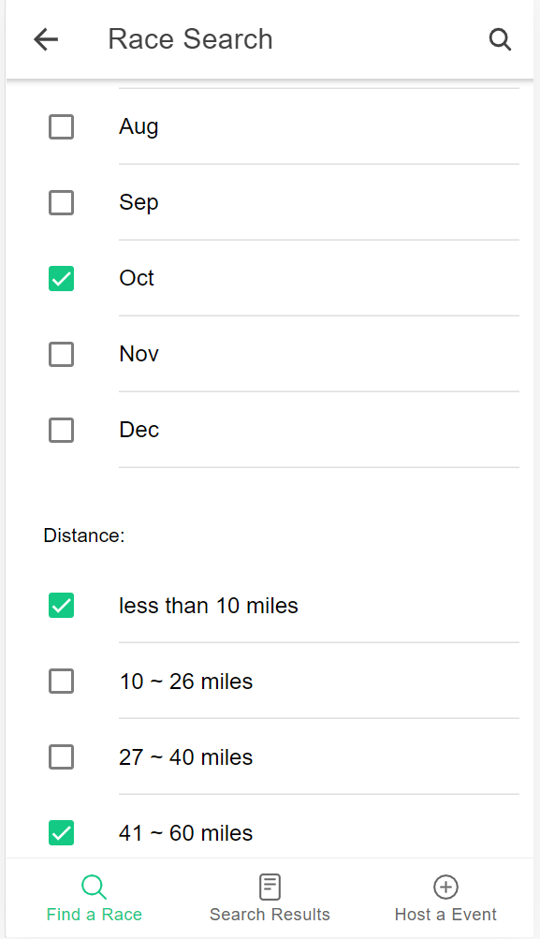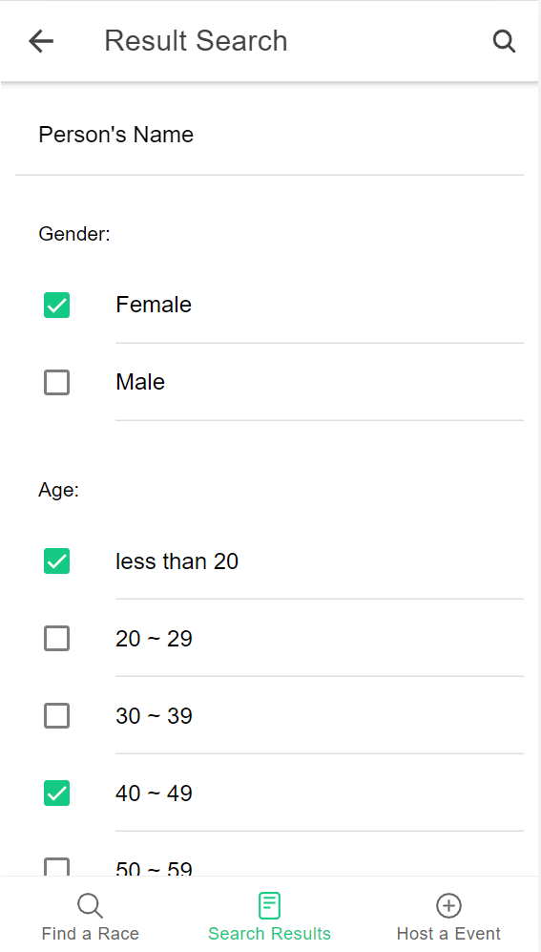

- RUNNER
- as runner, can create a profile
- as runner, can edit profile
- as runner, can register a race (showing the waiver form)
- as runner, can make payment(?) CC payment:Square ( USA payment system, free for developers)?
- as runner, can manage my races (eg. edit (address ) and cancel registration )
- as runner, can check my results
- as runner, can check my watch races

Mock UI:
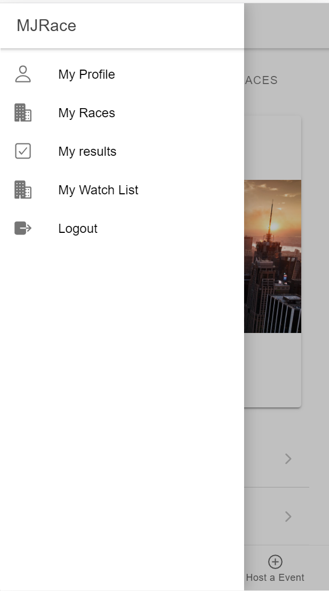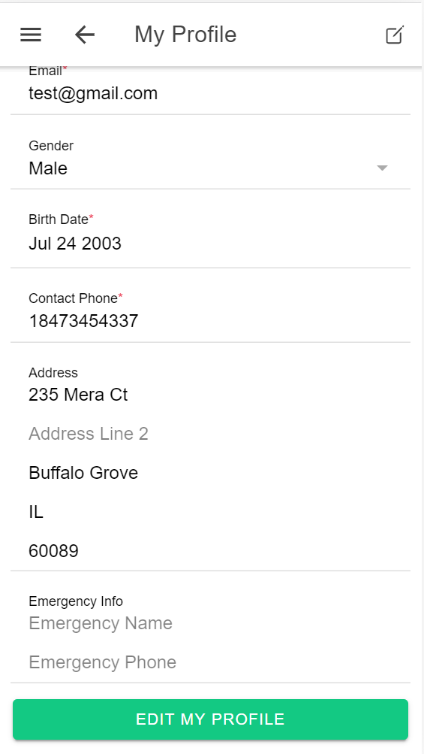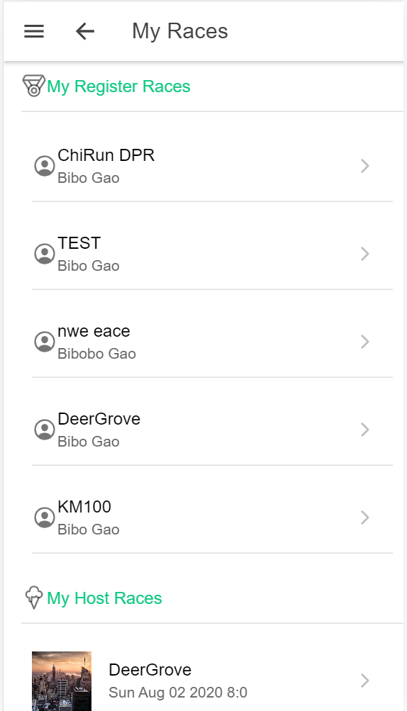
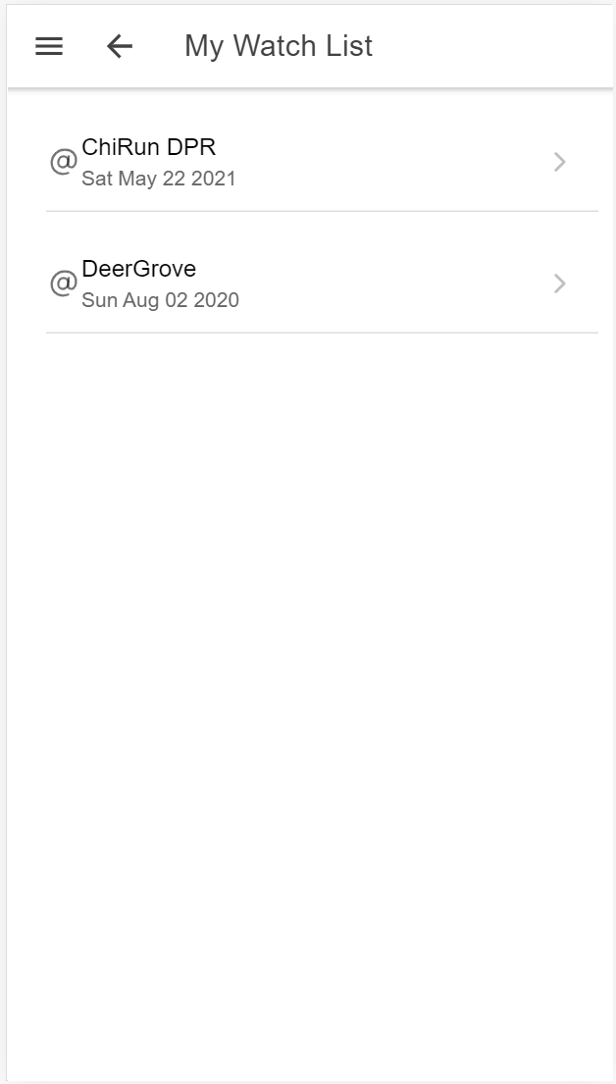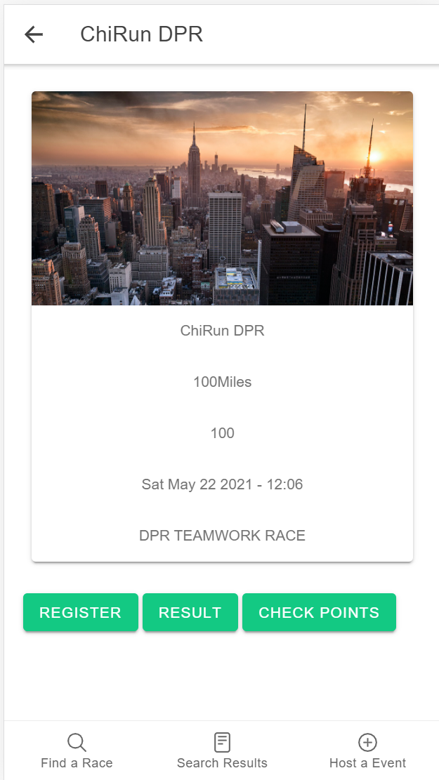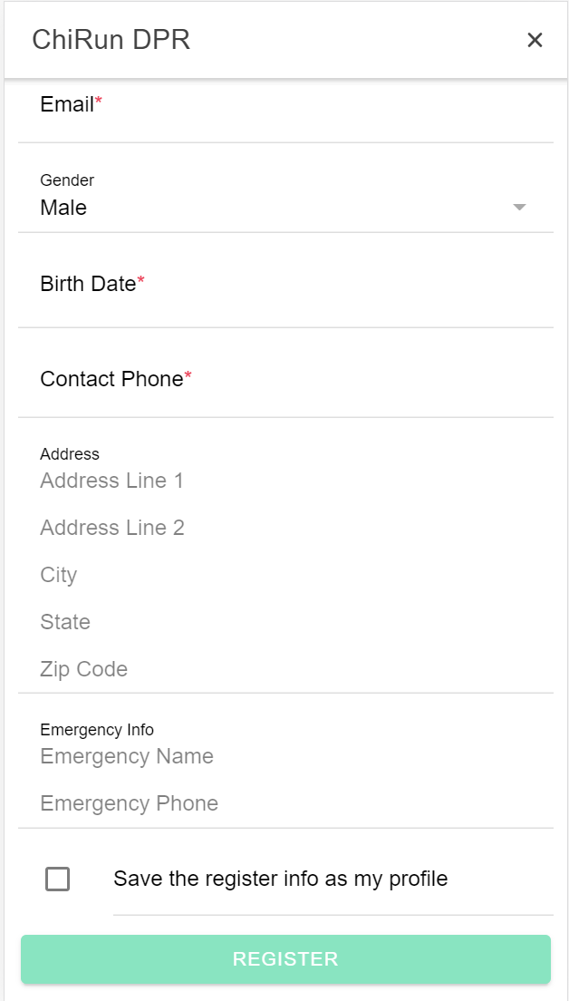

- Volunteer(TBD?)
- as volunteer, can create a profile
- as volunteer, can edit profile
- as volunteer, can see available races
- as volunteer, can see available jobs for a race
- as volunteer, can grab available jobs (self-assignment)

- Race director
- as RD, can create a race
- as RD, can edit and delete his/her created race
- as RD, can upload race results
- as RD, can edit race results
- as RD, can manual assign bib#
- as RD, can automatic assign bib#
- as RD, can set checkpoint info
- as RD, can set checkpoint timing info for runners
- as RD, can view all runners information whose registered
- as RD, can view all volunteers
- as RD, can group send customized email to all runners (name will change for each email)
- as RD, can group send customized email to all volunteers(name will change for each email)
- as RD, can create volunteer jobs (TBD?)
- as RD, can assign volunteer jobs (TBD?)
- as RD, can set priceMatrix(TBD?)

Mock UI:
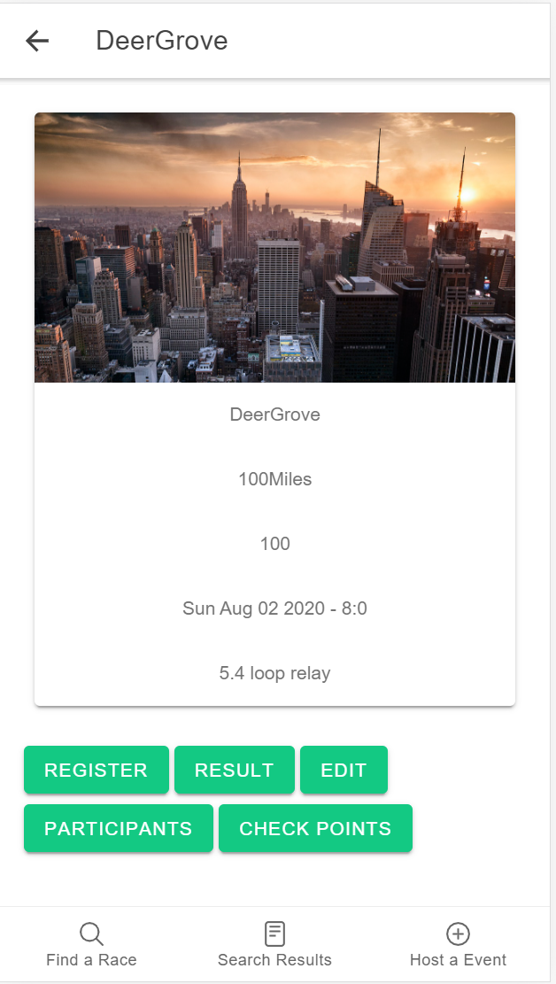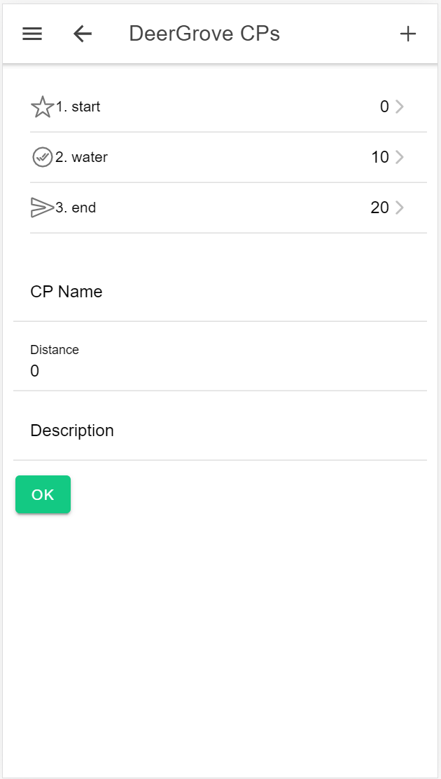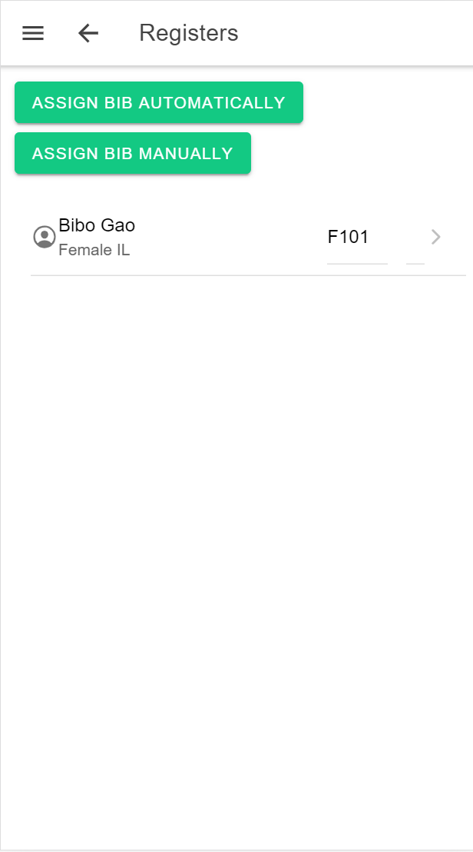
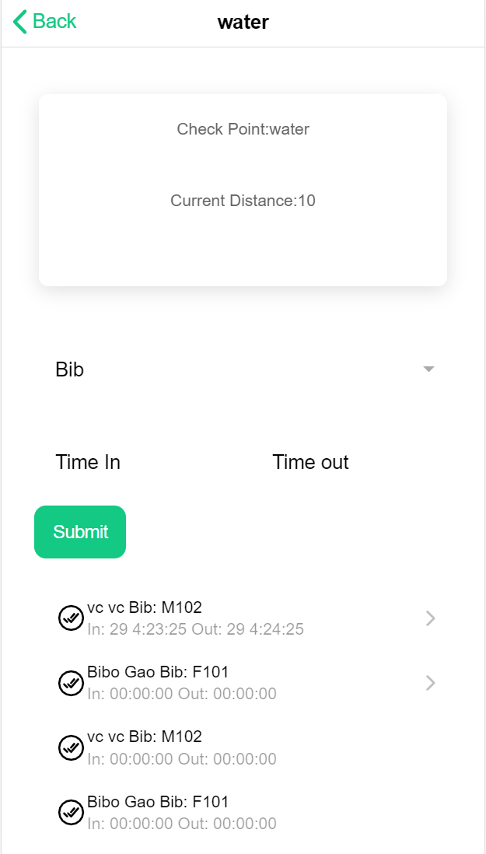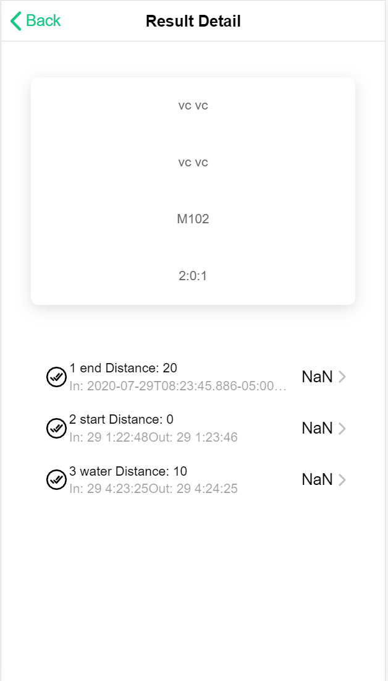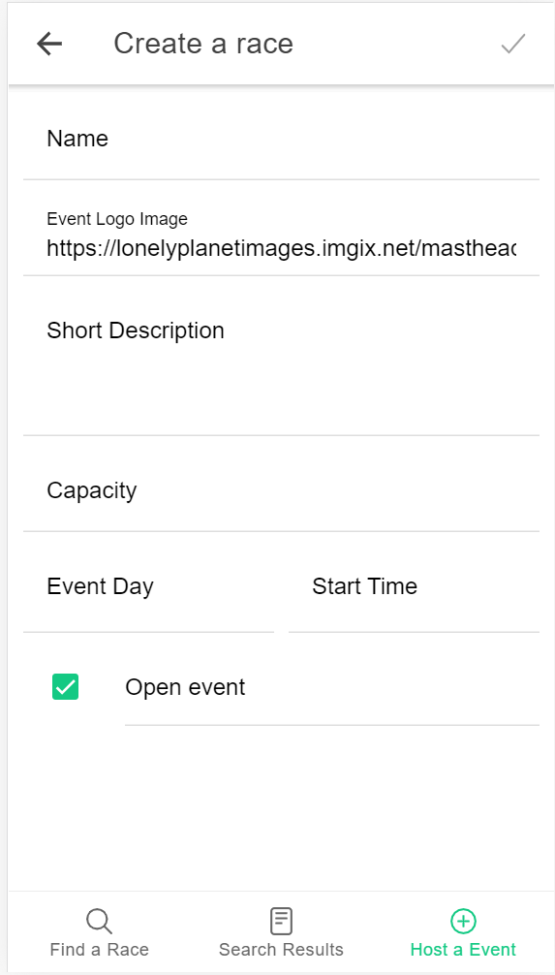

- Race Analysis and Report(TBD?)
- post-race data analysis
- age group ranking
- overall ranking
- finish rate
- avg time of finish etc
- send email/text when he/she crosses the finish line.
- report by email to runner if
- runner cross the finish line checkpoint
- the raceId is set active (under monitoring)

- Design:

- FRONTEND: Cordova + IONIC Framework (TBD?)

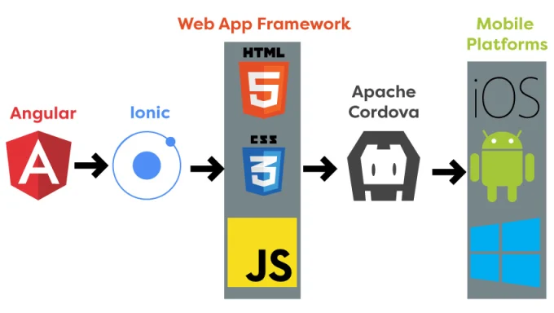
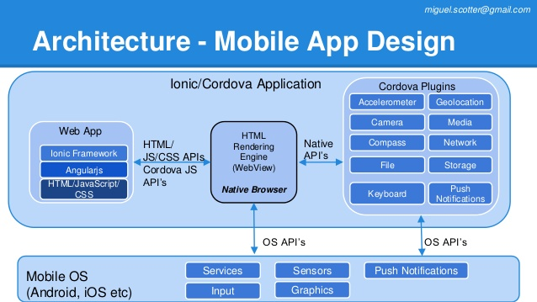

- BACKEND: Firebase (TBD?)
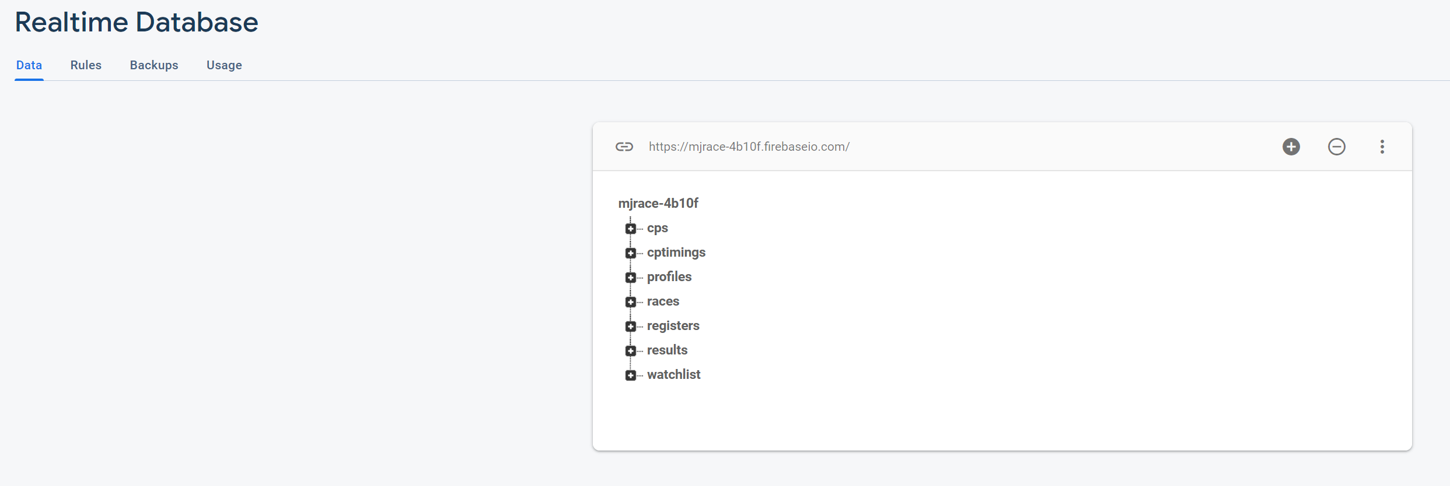

- Meeting To Do List:

- Decide the user stories and design
- Assign work

